**Ex 8 Basic Perl Programming**

**Date: 03.11.2020**

**Aim:**

To study and implement the basic Perl programming.

**Description**

Perl is a programming language developed by Larry Wall, specially designed for text processing. It stands for Practical Extraction and Report Language. It runs on a variety of platforms, such as Windows, Mac OS, and the various versions of UNIX. This tutorial provides a complete understanding of Perl.

**Perl Features**

* Perl takes the best features from other languages, such as C, awk, sed, sh, and BASIC, among others.
* Perl’s database integration interface DBI supports third-party databases including Oracle, Sybase, Postgres, MySQL, and others.
* Perl works with HTML, XML, and other mark-up languages.
* Perl supports Unicode.
* Perl is Y2K compliant.
* Perl supports both procedural and object-oriented programming.
* Perl interfaces with external C/C++ libraries through XS or SWIG.
* Perl is extensible. There are over 20,000 third-party modules available from the Comprehensive Perl Archive Network.
* The Perl interpreter can be embedded into other systems.

**Exercise**

**1. Perform arithmetic operations using Perl**

**Source Code :**

print "enter 2 numbers\n";

$a = <STDIN>;

$b = <STDIN>;

$c = $a + $b;

print 'Value of $a + $b = ' . $c . "\n";

$c = $a - $b;

print 'Value of $a - $b = ' . $c . "\n";

$c = $a * $b;

print 'Value of $a * $b = ' . $c . "\n";

$c = $a / $b;

print 'Value of $a / $b = ' . $c . "\n";

$c = $a % $b;

print 'Value of $a % $b = ' . $c. "\n";

**Output :**

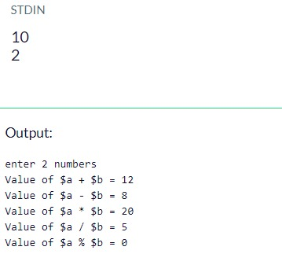

**2. Demonstrate all the escape sequences using print and say statements.**

**Source Code :**

print("Displaying text \n in new line by using \\n. \n");

print("Displaying text \t in new tab by using \\t. \n");

print("\"Printing in double quotes.\"\n");

print("\'Printing in single quotes.\'\n");

print("\L printing text in lower case.\n");

print("\U PRINTING TEXT IN UPPER CASE.\n");

**Output :**

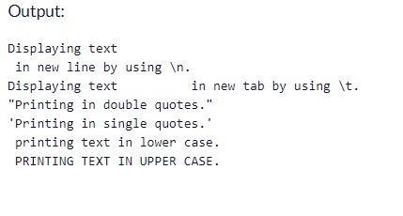

**3. Online shopping application.**

**Source Code :**

print("Enter the item:\n 1.Air conditioner(40k) \n 2.telivision(30k) \n 3.Refrigerator(20k) \n 4.Air cooler(15k) \n");

$c = <STDIN>;

print("Enter quantity\n");

$a = <STDIN>;

if ($c ==1)

{

$cost = $a * 40000;

print("cost of Air conditioner: Rs $cost\n");

}

elsif ($c ==2)

{

$cost = $a * 30000;

print("cost of telivision: Rs $cost\n");

}

elsif($c ==3)

{

$cost = $a * 20000;

print("cost of Refrigerator: Rs $cost\n");

}

elsif($c ==4)

{

$cost = $a * 15000;

print("cost of Air cooler: Rs $cost\n");

}

else

{

print("Invalid option");

}

**Output :**

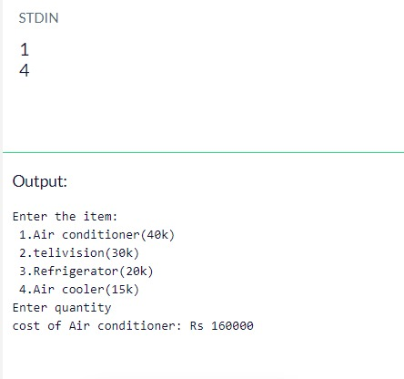

**4.Demonstrate arithmetic assignment operators in Perl.**

**Source Code :**

print("Enter a value\n");

$a = <STDIN>;

print("Enter Increment value\n");

$b = <STDIN>;

$b += $a;

print("Using increment assignment operator $b\n");

print("Enter decrement value\n");

$b = <STDIN>;

$b -= $a;

print("Using decrement assignment operator $b\n");

print("Enter Multiply value\n");

$b = <STDIN>;

$b *= $a;

print("Using multiplication assignment operator $b\n");

print("Enter division value\n");

$b = <STDIN>;

$b /= $a;

print("Using division assignment operator $b\n");

print("Enter modulus value\n");

$b = <STDIN>;

$b %= $a;

print("Using modulus assignment operator $b\n");

**Output :**

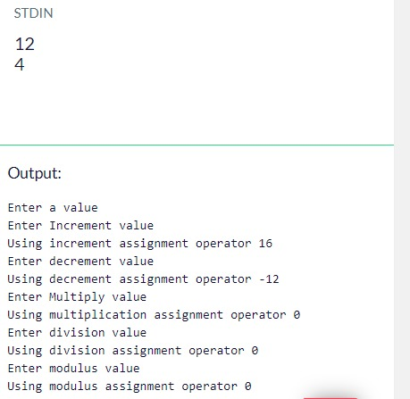

**Results:**

The study and implementation of basic Perl programming are studied and executed.

**Video :**

https://youtu.be/7zVIIeVljfQ